Assignment 4: Android Development
In this assignment you will build a simple Android app similar in spirit to the one shown at the end of the demo for the Android lesson. The app is a cipher tool that:
- Takes as input:
  - A Message to be encoded.
    - This input should be a non-empty string and contain at least one letter.
    - This input should be provided to the app through an EditText widget, initially blank.
  - A Shift Number.
    - This input should be an integer in the range 0 - 25 (inclusive).
    - This input should be provided to the app through an EditText widget, initialized to “0”.
  - A Rotate Number.
    - This input should be an integer >= 0.
    - This input should be provided to the app through an EditText widget, initialized to “0”.
- Produces as output
  - The Ciphertext, which is the string resulting from the specified shift and/or rotate in the input string.
    - All letters (a-z, A-Z) will be shifted by the number of characters specified in the Shift Number, as in a caesar cipher, and all other characters will remain unchanged. Capitalization is preserved.
“Cat” shifted 1 character would be “Dbu”.
    - All characters will be moved right by the number of characters specified in the Rotate Number, with letters from the end wrapping around to the front.
“Cat” rotated 1 character would be “tCa”.
This output should be shown using a non editable text field initially blank and (re)computed automatically whenever the Encode button is pressed. If the inputs are invalid, the output should be set to “” (i.e., the empty string), and all applicable error messages should be shown.

Error Messages
If the user provides an invalid input (see Item 1 above for what constitutes correct input values), the app should display an error message on the appropriate EditText widget using the error capabilities provided by the EditText widget. The error messages should be exactly (1) “Alphabetic Message Required”, applied to the Message field, (2) “Must Be Between 0 And 25”, applied to the Shift field, or (3) “No Encryption Applied”, applied to the Shift and Rotate fields for (1) an empty or letterless string message, (2) a blank or invalid shift number, and (3) both rotate and shift are zero. If you do this correctly, the results should be a floating text error message (whenever the field has focus), with error mark “”, right next to the EditText , as shown in the error Screenshots below. You may limit the Rotate Number field to positive numbers, or provide another error for that case.

Below are several (slightly cropped) screenshots of the app that provide examples of normal behavior and errors. You should also treat the screenshots as example test results and use them to check that your app behaves as intended.

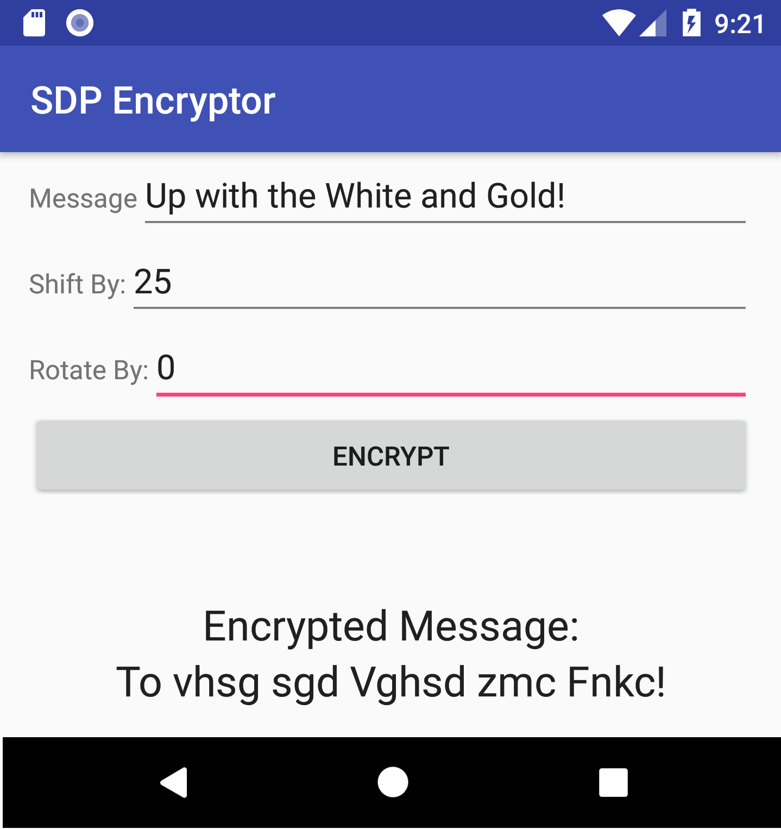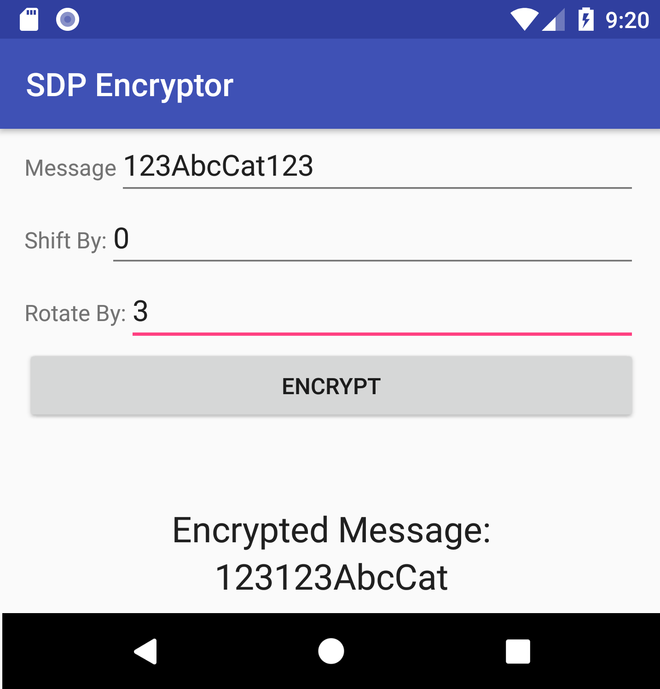
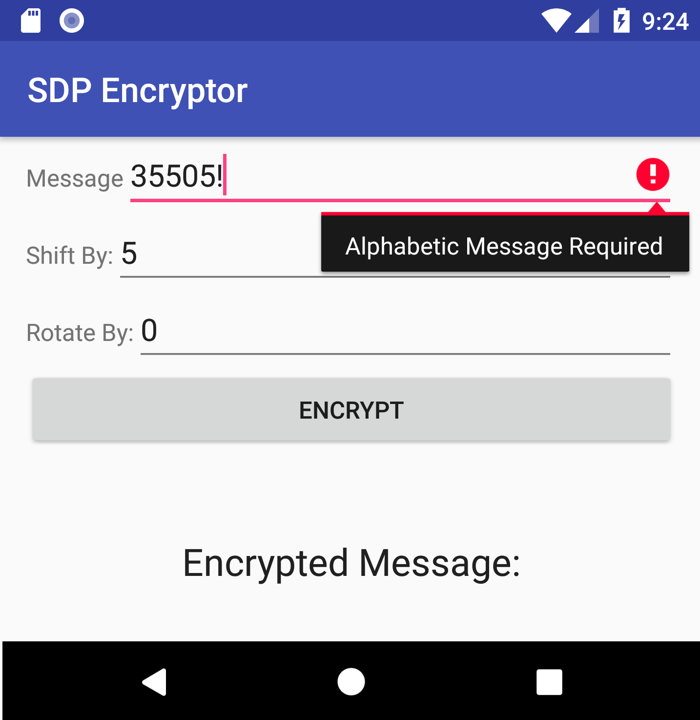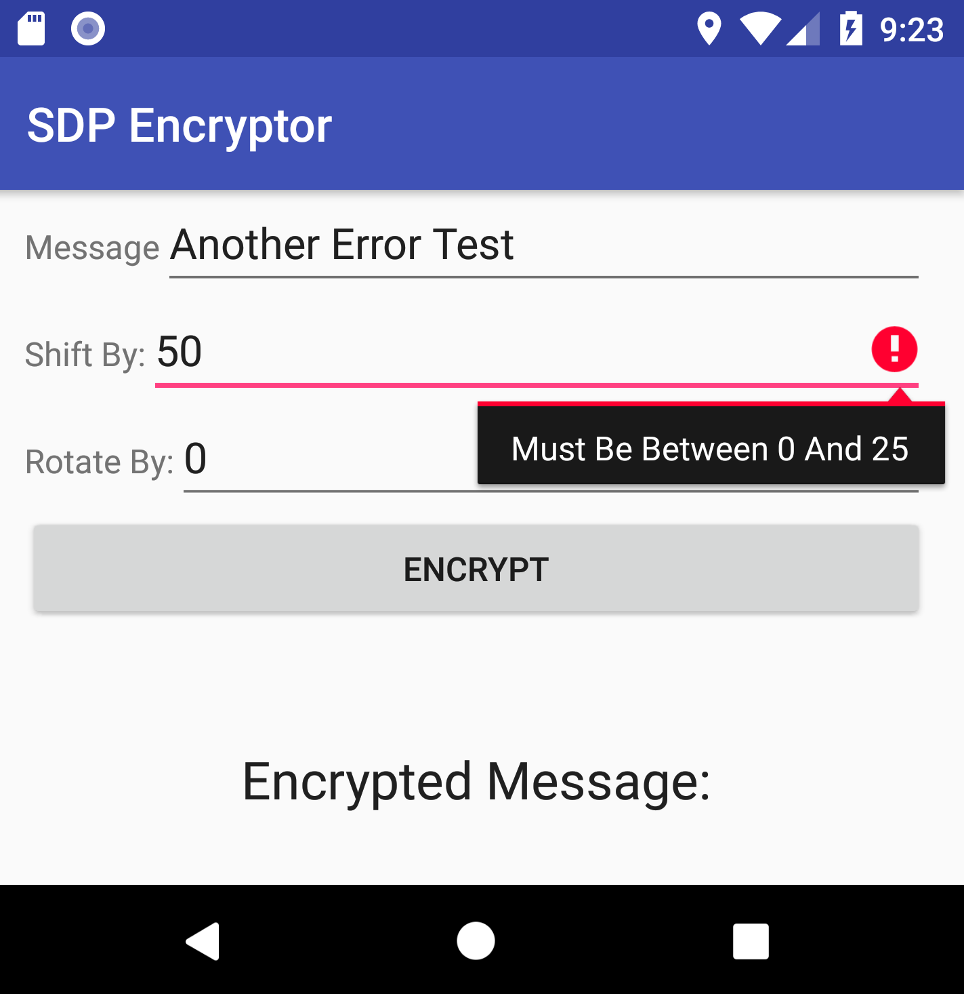
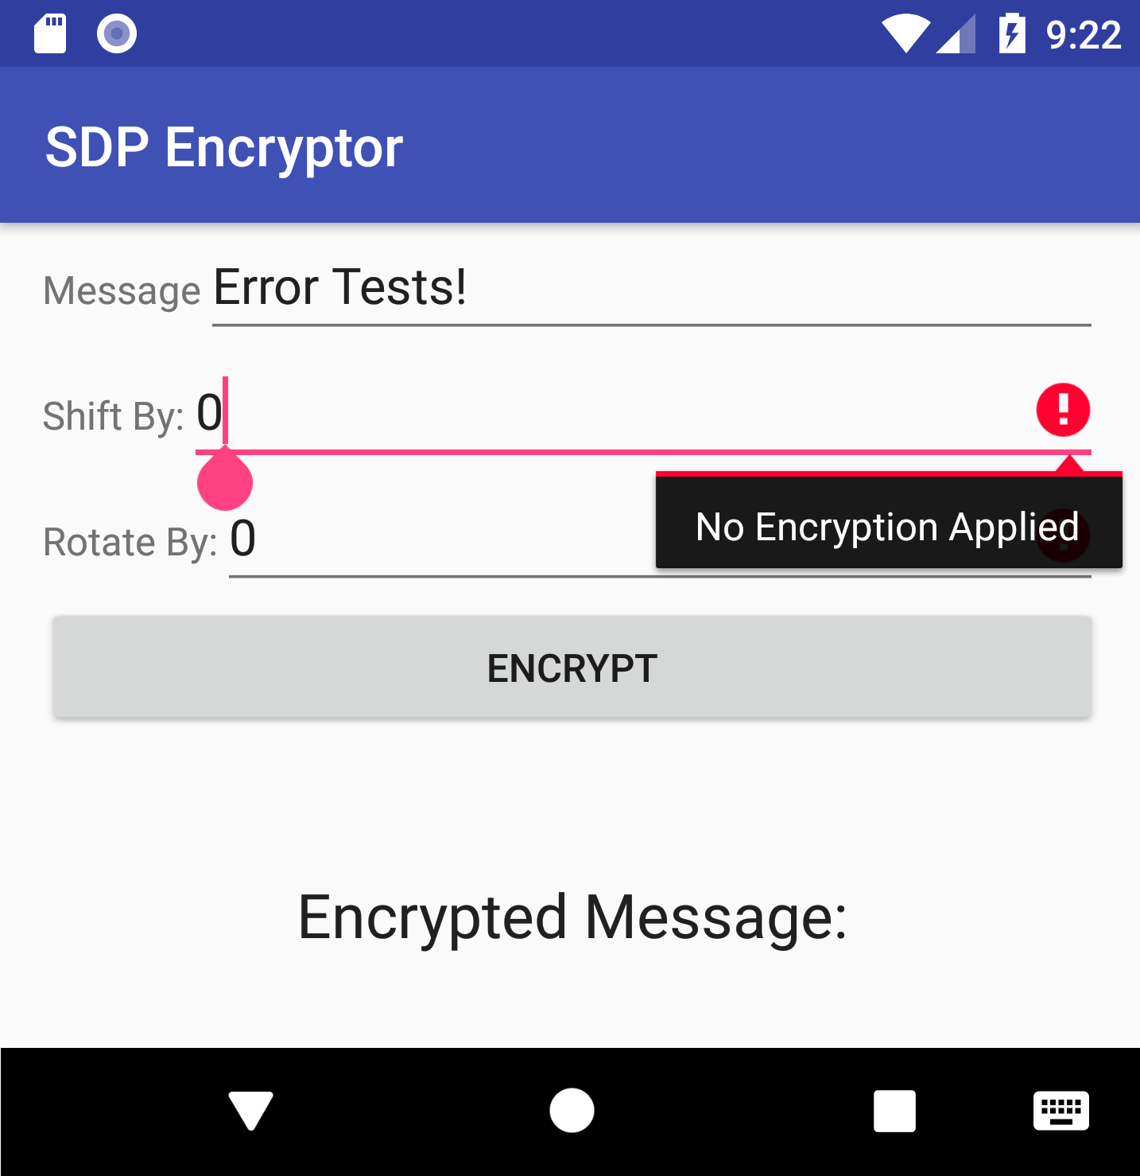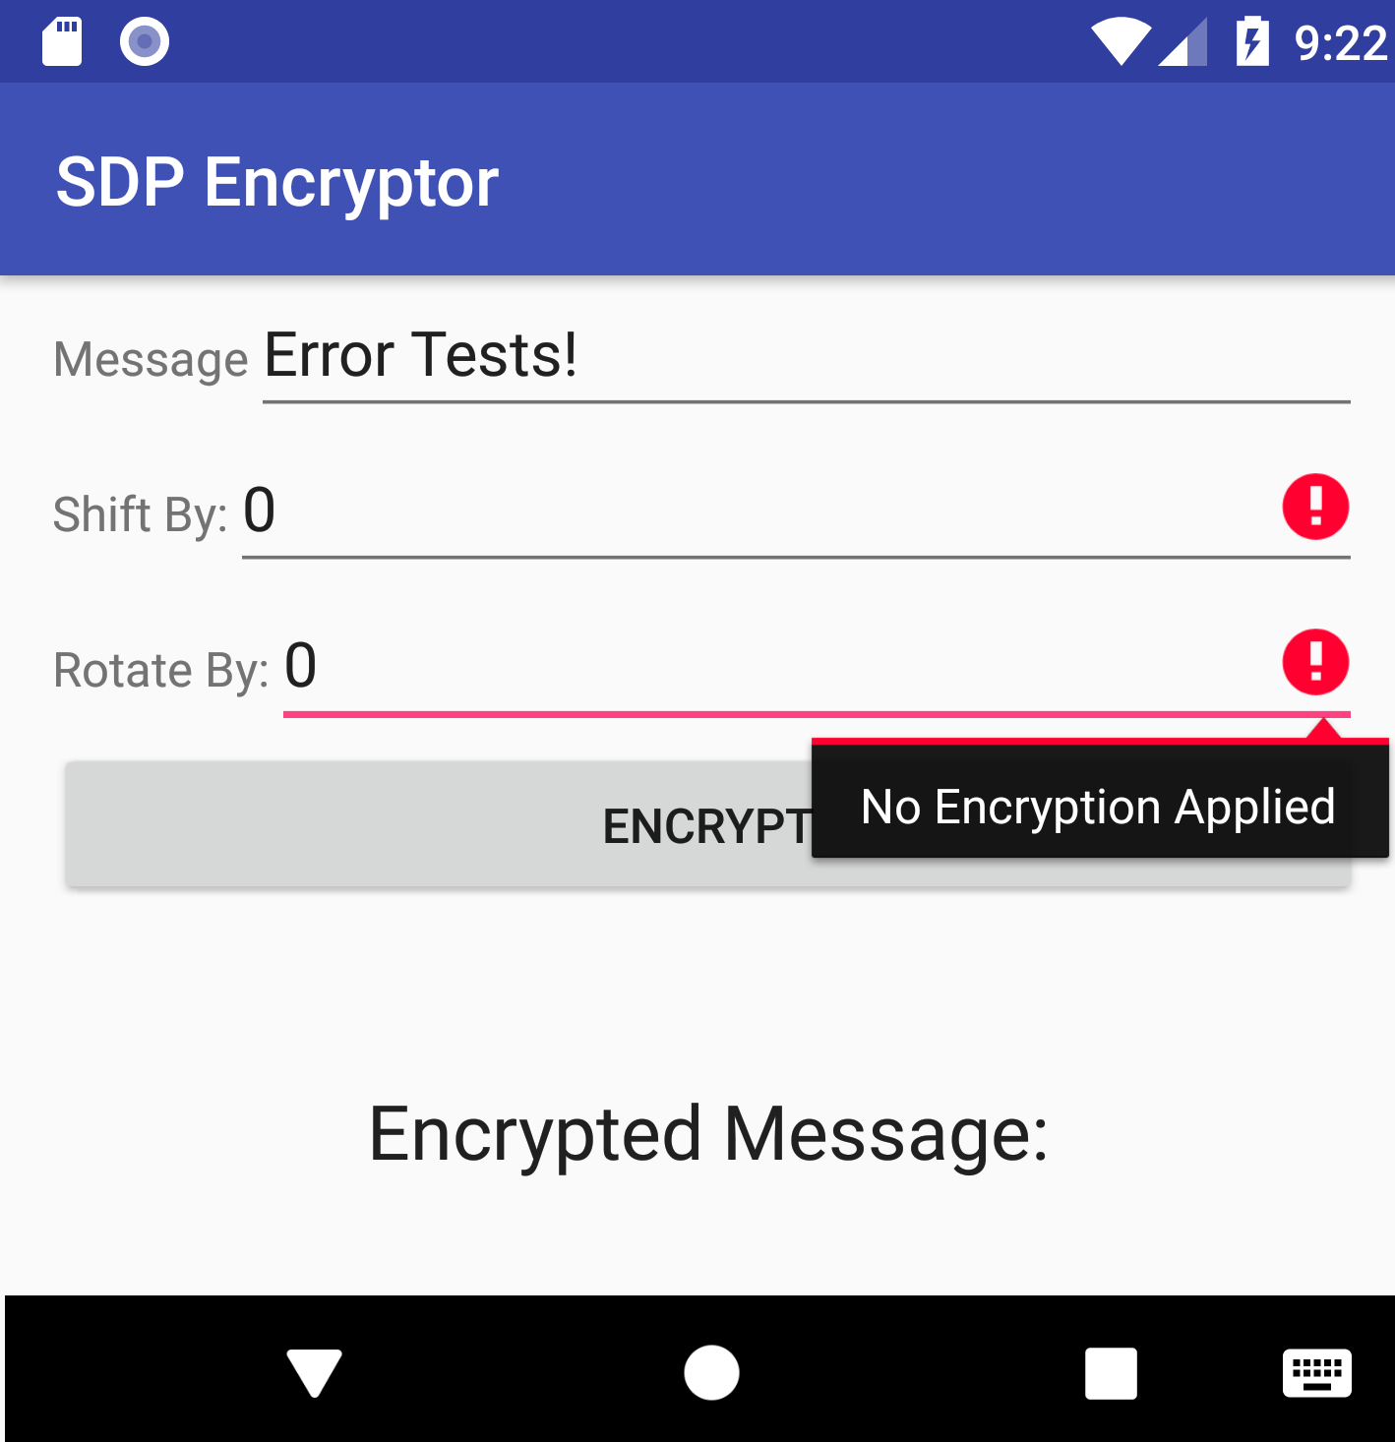

We suggest that you try to keep your user interface (UI) similar to the one shown, but you don’t have to. However, you must make sure to use exactly the same identifiers that we show in the next figure for the key widgets in the UI. This is very important, as we will use these identifiers to automatically test your app. The identifiers are also listed next to the figure for your (copy-and-paste) convenience.
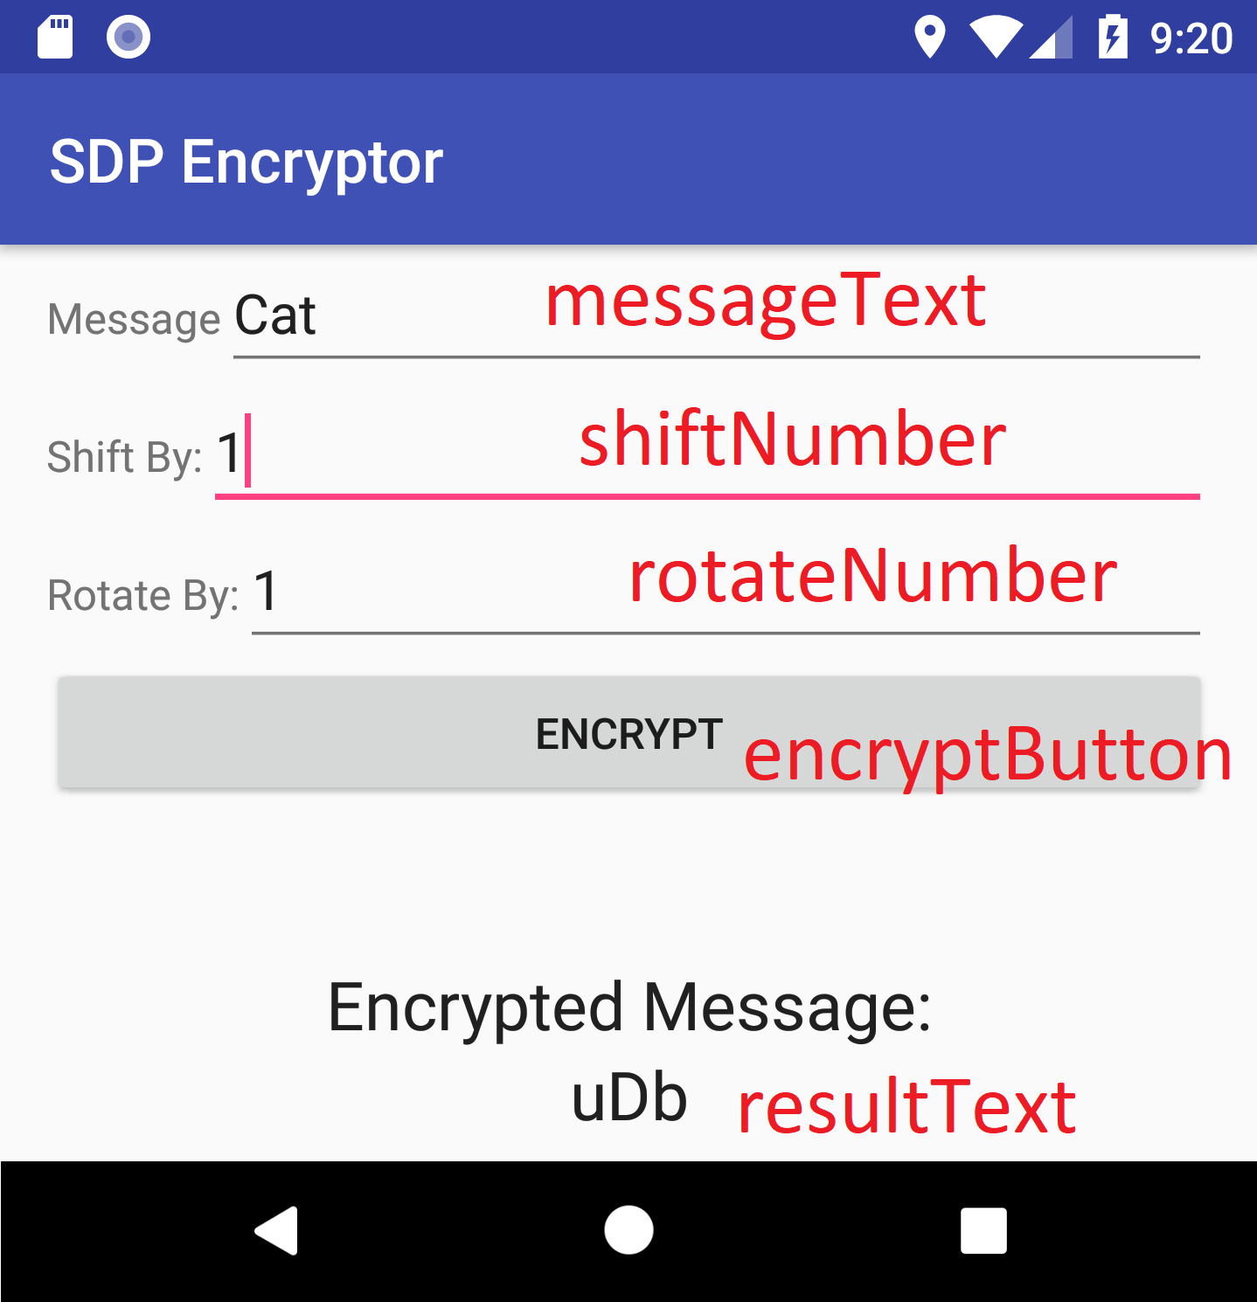

Identifiers:
- "messageText"
- “shiftNumber”
- “rotateNumber”
- “encryptButton”
- "resultText"

For example, in the XML layout file for your app, the entry for the text field used to input the Message should have the following ID: android:id="@+id/messageText".

Please note that, as described in the detailed instructions below, we took some steps to help you make sure that you used the right identifiers and strings.

Detailed Instructions
To complete the assignment you must perform the following tasks:
- In the root of your assigned individual GitHub repository, create a directory called Assignment4. Hereafter, we will refer to this directory in your local repo as <dir>.
- Using Android Studio, create an Android app project called “SDPEncryptor” in <dir>. Check that this generates a directory SDPEncryptor under <dir>.
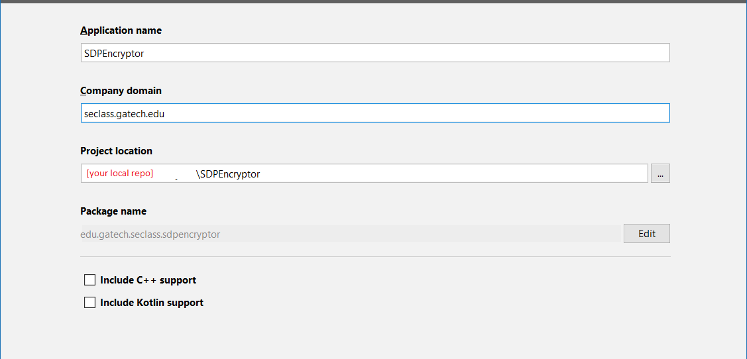
Ensure company domain is entered as “seclass.gatech.edu”, which will result in the package edu.gatech.seclass.sdpencryptor.
- Select “API 23: Android 6.0 (Marshmallow)” as the minimum sdk for your app.
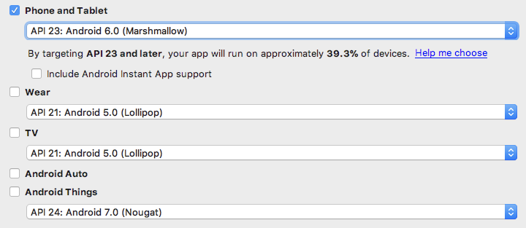
This minSdkVersion should be reflected in your build.grade file in the project.
- Create an “Empty Activity” and call it SDPEncryptorActivity
- Download and save the archive available here, which contains three files provided to help you make sure that you used the right identifiers and strings, as we mentioned above. These files will not check everything for you, but if you use them, they will prevent many simple errors. The files, which we describe how to use in the rest of the steps, are:
  - SanityCheck.java prevents your app from compiling if certain identifiers, your activity name, or your package name are incorrect.
  - strings.xml provides some constant strings that you can reference to avoid typos in error messages. You are welcome to edit this file or add additional strings to it, but please keep in mind that our tests will expect the identifiers and error messages to match the ones provided, exactly.
  - AssignmentExamples.java contains Espresso tests similar to the tests we will run on your code for grading.
- Extract strings.xml from the archive and copy it to your project at <dir>/SDPEncryptor/app/src/main/res/values
- Implement the primary functionality of the app in SDPEncryptorActivity.
- Define the IDs for the key widgets in the app as described above.
- Extract SanityCheck.java from the archive and copy it to your project at <dir>/SDPEncryptor/app/src/main/java/edu/gatech/seclass/sdpencryptor
  - Rebuild the project in Android Studio.
  - If the project does not compile, and you have added all the required identifiers to your layout, it should mean that there are issues with your activity name/package, your identifiers, or both. Make sure to correct your project, and not the provided SanityCheck.java file.
- Extract AssignmentExamples.java from the archive and copy it to your project at <dir>/SDPEncryptor/app/src/androidTest/java/edu/gatech/seclass/sdpencryptor
  - Add the necessary dependencies to your build.gradle.
  - Rebuild the project in Android Studio
  - Run the tests by either setting up a new run configuration or right clicking the file and choosing “Run ‘AssignmentExamples’”.
- Create a manual.md file (in Github flavored MD format) that describes how to use the app. Put the file in <dir>, not in SDPEncryptor. Think of this file as a (very concise) user manual. You should not need more than one page for the manual. It should use at least some markdown formatting. Feel free to add screenshots to the manual, but that is not mandatory. You can view your markdown file in Github or using an MD viewer.
- Commit and push your project from within Android Studio (or from the command line, if you know what you are doing). Doing it from Android Studio should help ensure that all the required files are committed. Be sure to use your existing, assigned repository, rather than creating a new repository from Android Studio. No matter how you commit and push your project, we strongly recommend that you (1) clone your repo in a different directory, (2) open the project in Android Studio from this new directory, (3) compile the project, and (4) run it on a (virtual) device that does not already have the app installed (i.e., you may have to remove the app from the device if you have ran the app there before).
- As usual, submit your solution by doing the following:
  - Pushing your code to your assigned remote GitHub repository.
  - Submitting the final commit ID for your submission on Canvas. (You can get your commit ID by running "git log -1" and copying the hexadecimal ID it produces.)

Notes
- You should commit early and often. Verify that you are able to correctly push your code to the assigned repository as soon as possible. You can perform multiple commits and work on multiple branches as you produce your solution. This is not only fine, but actually encouraged. Just make sure that your final solution is committed to the master branch.
- You should complete the assignment using Android Studio 3.*. Earlier versions of Android Studio may work as well, but we have not tested our solution there.
- Feel free to take inspiration from online resources when developing your app. However, be careful not to copy and paste entire pieces of functionality. The tool we use to identify cases of plagiarism is likely to have access to the same online resources that are available to you.
- In case you want to use automated testing for your app, you may find Espresso and either Barista (documentation here) or Android Studio Test Recorder useful. This is completely optional; that is, developing tests for your app, whether manual or automated, is not required.
- If you decide to use Espresso yourself, or run our provided tests, here’s a couple of potentially useful tips:
  - If anything covers your fields or buttons (even invisible boxes), the tests may fail to complete.
  - If you use buttons that call private methods, Espresso may be unable to click the button.
  - Turn off animations in your AVD, particularly if the tests return AmbiguousViewMatcherException.

